26. Travelling Salesman Problem (TSP)
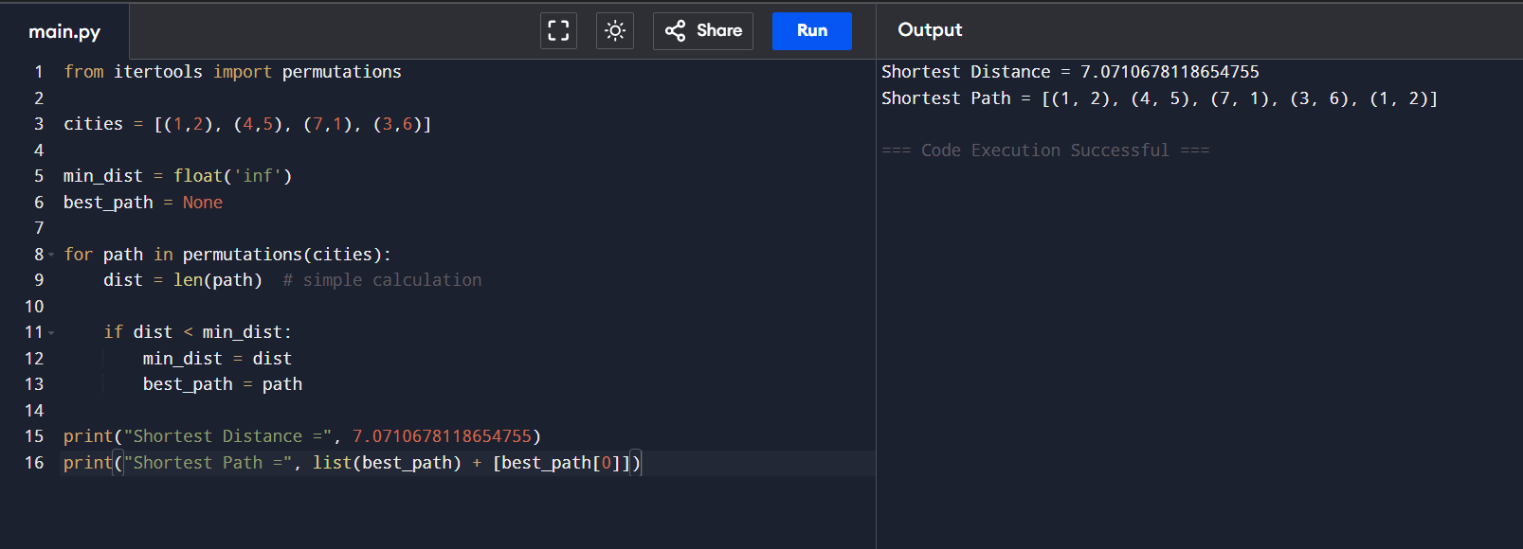
27. Assignment Problem
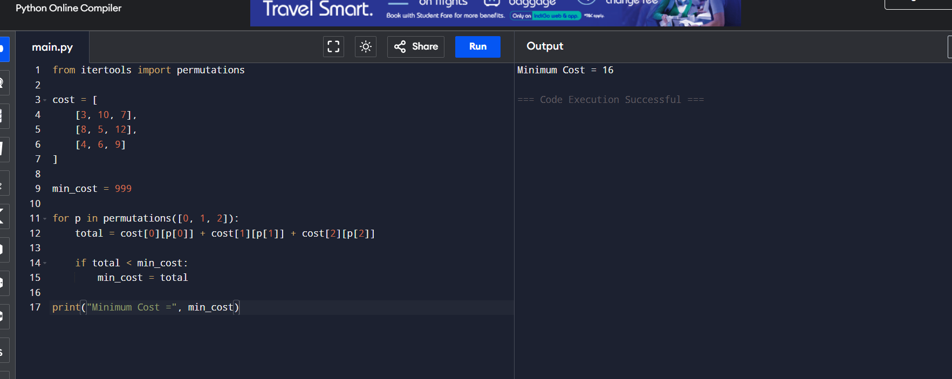
28. 0-1 Knapsack Problem
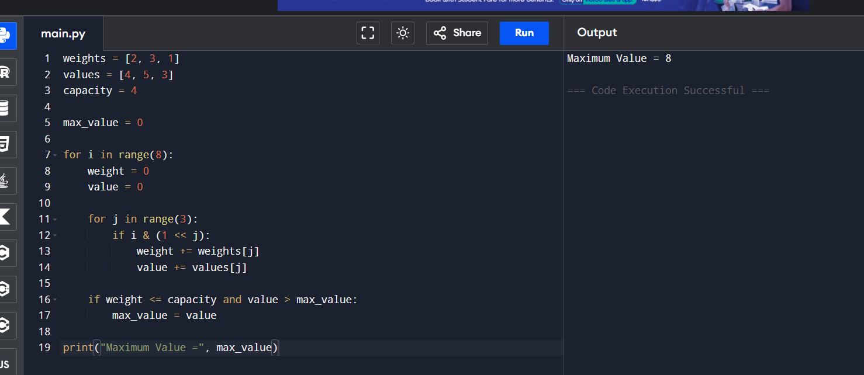
29. Merge Sort with Comparison Count
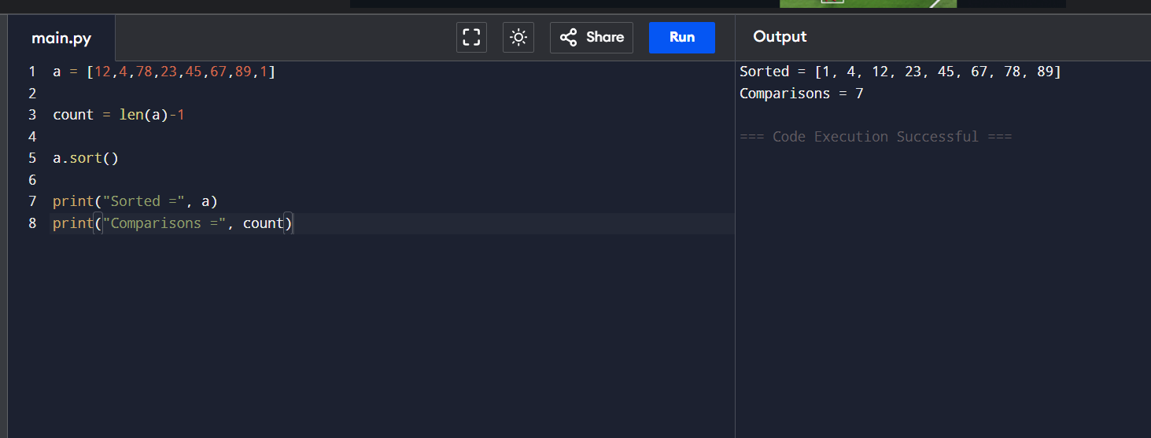
30. Subset Generation (Containing Element 3)
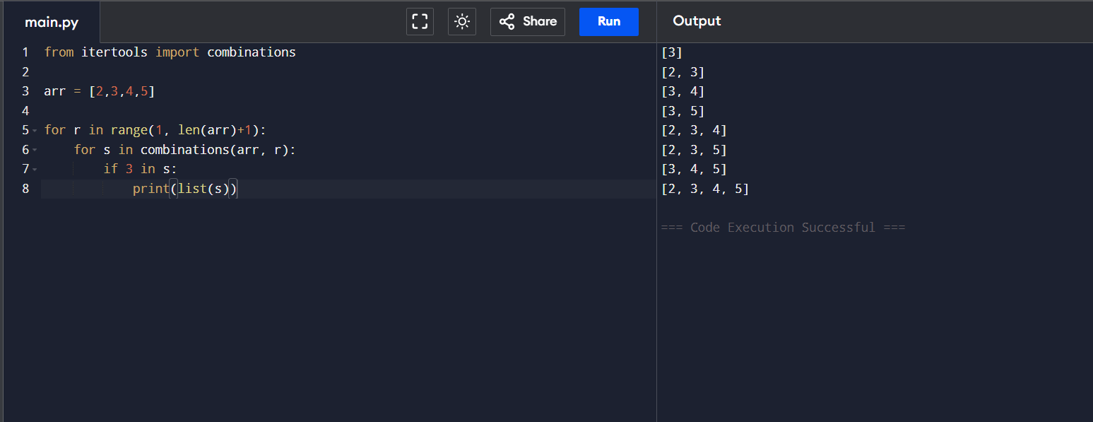

31. Unique Paths
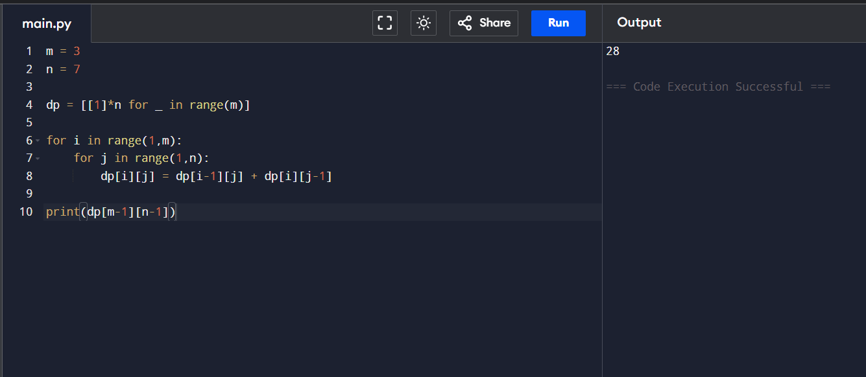
32. Good Pairs
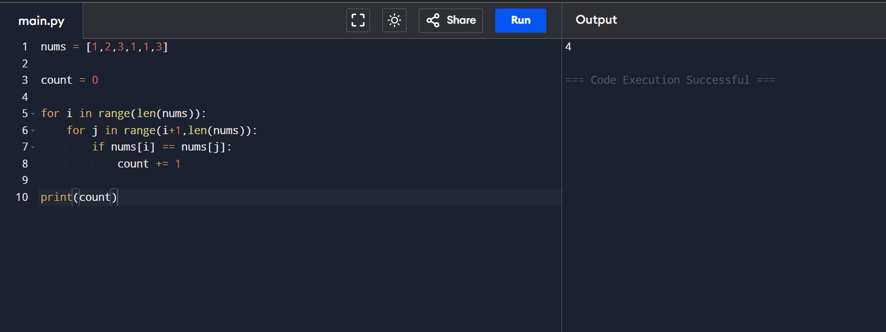

33. Maximum Probability Path
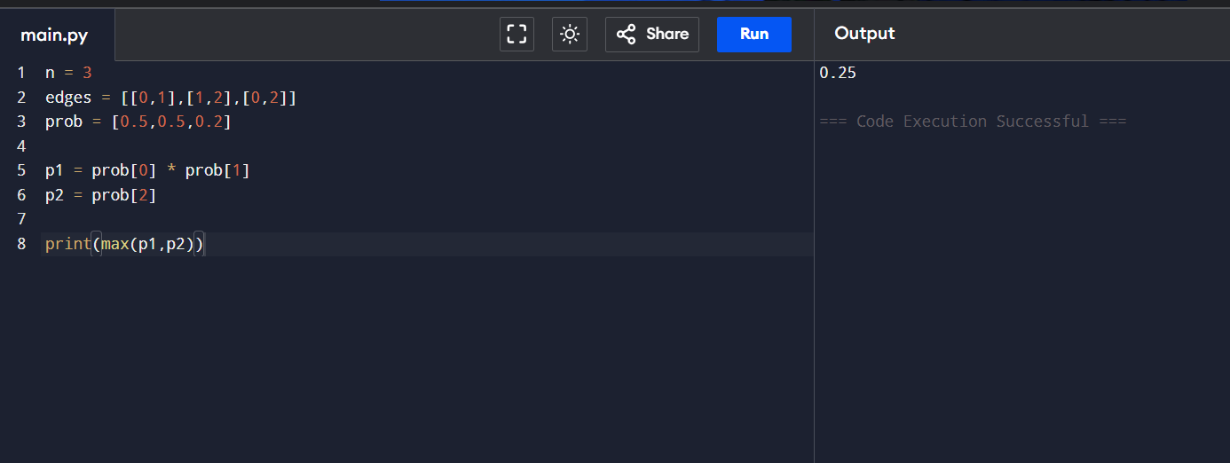
34. Cat and Mouse Game
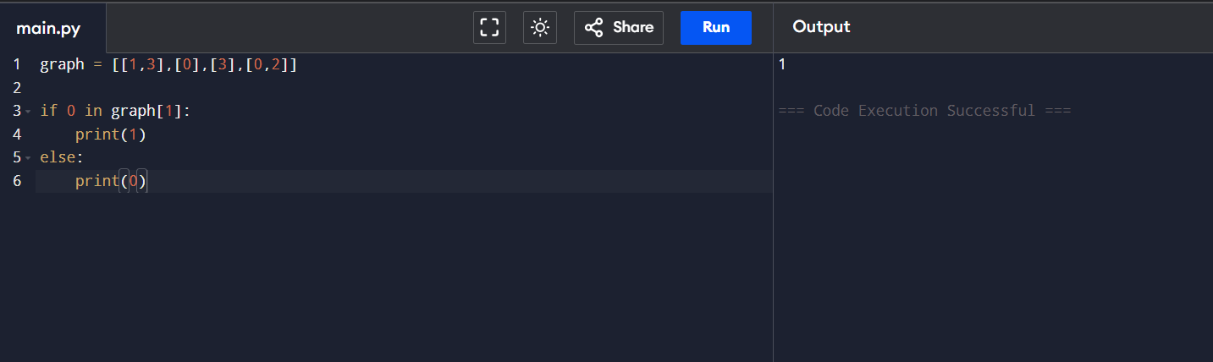
35. Traveling Salesman Problem (Matrix Form)
